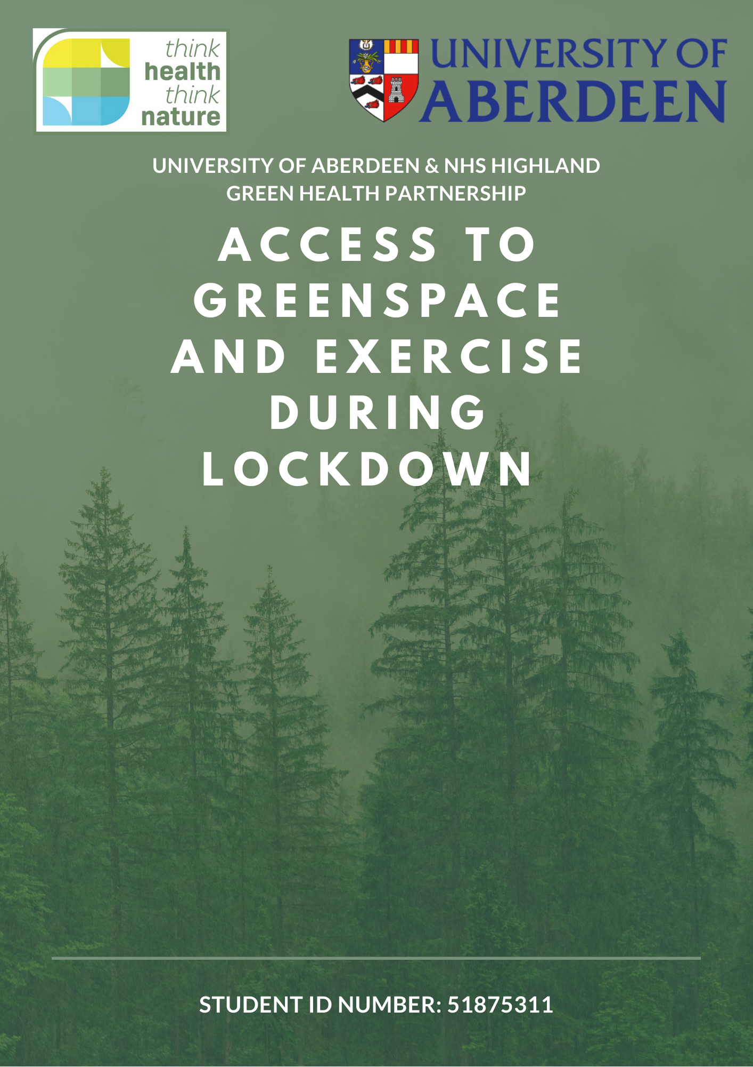

Table of Contents
Introduction 2
Aim 2
Background 2
Method 4
Results 5
Discussion 5
Evaluation 5
Conclusion 5

Introduction

Aim
This project aims to establish the effect of lockdown on the use and access to greenspace and exercise patterns during the COVID-19 pandemic. In particular:
- focusing on the change to people’s behaviour - before, during and post lockdown;
- the barriers presented to people getting outside and the resolutions;
- differences between two groups of people: key workers and those who were asked to shield;
- the impact of the pandemic on people’s physical, mental and emotional health.

Background:
The World Health Organisation (WHO) declared COVID-19, also known as coronavirus, a pandemic on the 11th of March 2020. In response to increasing cases and related deaths, the UK entered a lockdown on the 23rd of March 2020. People were required to stay at home: except for once daily exercise, an essential shopping trip, a medical need or to attend work (for those that could not work from home). All non-essential businesses were required to close, and public gatherings were banned.

During the COVID-19 lockdown, people relied heavily on being able to get outside for their daily exercise. However, restrictions prevented travel further than 5 kilometres, meaning people had to find greenspace in their immediate area.

Greenspace Scotland defines greenspace as: “any vegetated land or water within an urban area; this includes:
- parks, gardens, playing fields, children’s play areas, woods and other natural areas, grassed areas, cemeteries and allotments
- green corridors like paths, disused railway lines, rivers and canals
- derelict, vacant and contaminated land which has the potential to be transformed” (https://www.greenspacescotland.org.uk/what-is-greenspace)

According to UK data, one in eight British households do not have access to either a shared or private garden. However, 72% of the UK population is estimated to live within 900m of a public park or garden. (https://www.ons.gov.uk/economy/environmentalaccounts/articles/oneineightbritishhouseholdshasnogarden/2020-05-14) In addition to this, those of a lower socioeconomic status are known to have less access to greenspace and therefore are the least likely to reap the benefits of greenspace. (https://www.thelancet.com/journals/lancet/article/PIIS0140-6736(08)61689-X/fulltext)

Physical activity reduces the risk of many non-communicable diseases such as type 2 diabetes, stroke, cardiovascular disease and obesity. The recommended UK guidelines for adults are 30 minutes of activity per day. Although greenspace is not necessarily the only way to be active, some studies have shown a link between the proximity to greenspace and those reaching their recommended activity levels. (researchbriefings.files.parliament.uk › POST-PN-0538) In addition to this, greenspace is well known for its mental health benefits: improved mental wellbeing and lowered levels of depression, anxiety and mood disorders. More areas of greenspace lead to better mental health outcomes. (https://www.ncbi.nlm.nih.gov/pmc/articles/PMC3987044/) As well as this, children exposed to greenspace have a lower risk of developing psychiatric disorders later in life. (https://earthobservatory.nasa.gov/images/145305/green-space-is-good-for-mental-health) People who move to areas with more greenspace report an improvement in mental health, whereas those that move away from these areas report a decrease in their mental health. (https://pubs.acs.org/doi/10.1021/es403688w) Greenspace can also improve emotional health - nature has been indicated to reduce stress and anger. (researchbriefings.files.parliament.uk › POST-PN-0538)

In Philadelphia, a study found that by increasing greenspace in sections of the city, there were subsequently fewer gun assaults, vandalism and criminal activity. The inhabitants of these areas also reported lower levels of stress and greater uptake of physical activity. (https://www.ncbi.nlm.nih.gov/pmc/articles/PMC3224254/)

During the COVID-19 pandemic, the NHS identified 2.2 million who should shield from the virus. These people were advised not to leave their house at all from the 23rd of March. Initially, those shielding were advised this was for 12 weeks, but the advice was then extended to the 30th of June, a total of 15 weeks. (https://www.england.nhs.uk/coronavirus/wp-content/uploads/sites/52/2020/06/C0624-shielding-letter-to-nhs.pdf) Those shielding were deemed extremely clinically vulnerable - the government and Public Health England released a list of adults who should shield, but the decision was also based on the clinicians. (https://www.gov.uk/government/publications/guidance-on-shielding-and-protecting-extremely-vulnerable-persons-from-covid-19/guidance-on-shielding-and-protecting-extremely-vulnerable-persons-from-covid-19)

Key workers were critical to the functioning of the country during the pandemic, providing essential services. They can be separated into 5 categories, which were originally used to sort priority of testing:
- “Priority Group 1A: Staff delivering NHS services, providing social care to protect and care for the most vulnerable, all NHS staff and independent contractors working for the NHS.
- Priority Group 1B: Staff with face-to-face roles in residential institutions with people in the care of the state and those who are working essential services with niche roles, where service resilience is at risk.
- Priority Group 2: Essential workers in critical national infrastructure fundamental for safety and security, and life-line services.
- Priority Group 3: Staff directly involved in delivering other essential services.
- Priority Group 4: Staff and volunteers in third or public sector organisations including unpaid carers, and staff in nationally or locally significant industry important to economic sustainability and growth.”
(https://www.nhsinform.scot/illnesses-and-conditions/infections-and-poisoning/coronavirus-covid-19/workers-travellers-and-community-support/coronavirus-covid-19-advice-for-key-workers)

Method
An online survey gathered data from around the Inverness area. The survey was open to the public on Google Forms for two weeks: from the 9th of November 2020 to the 23rd of November 2020. In order to provide an incentive for the completion of the survey, NHS Highland Green Health Partnership provided a £50 shopping voucher for the prize draw. A copy of the survey can be found in Appendix 1, along with the terms and conditions for the prize draw.
The survey was distributed through the NHS Raigmore Anaesthetics department, NHS Highland Green Health Partnership (Think Health, Think Nature), Highland Third Sector Interface, Culcabock and Drakies Community Council Facebook Page, Hilton Parish Church Facebook Page, Culloden and Smithton – Local People Programme Facebook page, PARCS – Preserve and Revamp Culloden & Smithton Facebook page, King’s Inverness Facebook Page and Paths for All. In order to reach out to those who may not be online, group walks were attended to circulate the survey further.
In total, there were 534 responses. Once the survey had closed all those from outside the Highland area postcodes were removed, 502 responses remained.
These can be broken down into subcategories:
Total Number of Participants | 502 | 100%
Location:  IV1 1  IV1 3  IV2 3  IV2 4  IV2 5  IV2 6  IV2 7  IV2 8  IV10  IV11  IV12  IV13  IV14  IV15  IV16  IV17  IV18  IV19  IV20  IV21  IV22  IV23  IV24  IV25  IV26  IV27  IV28  IV3 5  IV3 8  IV4 7  IV5 7  IV6 7  IV7 8  IV8 8  IV9 8  IV40  IV41  IV42  IV43  IV46  IV47  IV49  IV51  IV52  IV53  IV54  IV55  IV56  IV63  KW10  KW12  KW14  KW36  KW56  KW86  KW96  PH20  PH21  PH22  PH23  PH24  PH25  PH26  PH31  PH33  PH34  PH36  PH37  PH41  PH49  PH50  Not answered | 2  1  12  11  5  11  17  1  5  18  16  5  10  8  2  4  3  5  4  4  5  7  14  12  18  22  4  11  19  4  2  12  27  5  3  22  1  4  2  1  4  3  9  2  5  4  2  1  5  7  1  28  3  1  2  4  3  7  8  4  5  3  6  4  15  2  2  1  1  2  3  16
Key Workers:  Category 1a  Category 1b  Category 2  Category 3  Category 4 | 251  154  7  20  48  2 | 50%
Those Advised to Shield | 67 | 13.4%

Results
Theme 1: Access to Greenspace
Theme 1: The majority, 97.3%, of people had access to a garden, and everyone surveyed were aware of their local greenspace. This is higher than the UK average, where only 87% of the population are estimated to have access to a garden. (https://www.kingsfund.org.uk/sites/default/files/field/field_publication_file/Gardens_and_health.pdf) This may be as the Highlands has only one city, therefore, tower blocks are less commonly seen.
Theme 2: Frequency of Activity
Theme 2a: Access to the outdoors increased during the pandemic. 260 (51.8%) people accessed the outdoors every day before the pandemic, and this increased to 281 (56.0%) during the strict lockdown.
Theme 2b: A greater number of those shielding never accessed the outdoors during the strict lockdown compared to the general population. 23.9% of those who were asked to shield never accessed the outdoors during the strict lockdown. This is significantly higher when compared the general population, of which 2.5% never accessed the outdoors during the strict lockdown. However, 37.3% of the shielding population accessed the outdoors every day during the strict lockdown, but this is still less than 54.7% of the general population.
Theme 2c: Marginally fewer key workers engaged in outdoor activity daily during the strict lockdown. 50.6% of key workers engaged in outdoor activity daily, which is slightly lower than the rest of the survey respondents of whom 54.2% engaged daily.
Theme 3: Change in Frequency of Activity
Theme 3a: Overall, 39.1% of participants had no change to their outdoor activity since the start of the pandemic, while 35.5% increased their activity, and 25.5% decreased their activity.
Theme 3b: 37.7% of people plan to increase their outdoor activity in the future, while 55.9% plan to continue the amount of activity they do. A very small amount of people, 0.5%, plan to decrease their outdoor activity while 5.3% are unsure.
Theme 4: Outdoor Activity
Theme 4: The activity people engaged in the most was walking. This was constant throughout all the time periods. However, more people reported to be walking before the pandemic (92.8%) than during the strict lockdown (84.1%) although this increased following lockdown easing (89.8%).
Gardening and growing also increased from pre-pandemic levels of 286 of responses (57.0%) to 329 (65.5%) of responses during the strict lockdown, a change of 8.5%. This could be due to people having more time or the change in weather and seasons as lockdown progressed.
People also engaged in jogging / running, cycling, outdoor volunteering, outdoor learning, relaxation, yoga, mindfulness and outdoor sports.
Theme 5: Past Barriers to Outdoor Activity
Theme 5a: In the past six to nine months, the most commonly faced barriers by people were poor weather (38.7%), lack of time (33%) and other people behaving inconsiderately or irresponsibly (20.4%).
Theme 6: Barrier to Future Outdoor Activity
Theme 6: The most commonly identified barriers preventing outdoor activity in the future 6 months were weather, lighting, confidence, lack of cycle routes, accessibility, travel restrictions and COVID-19.
Theme 6a: Weather
Many people felt that the poor winter weather common in the Highlands would prevent them accessing the outdoors. The excessive rainfall leads to waterlogged or muddy paths, making them more hazardous for the more vulnerable members of society. In addition to this, the colder conditions can cause ice formation, increasing the slip risk. In order to improve this, well-used paths could have better drainage, be cleared of leaves and gritted in the colder weather. Another recommendation is weather protected outdoor spaces, allowing people to get outside into nature and meet up socially even when weather conditions are poor. In addition to this, children from lower-income households could be provided with waterproofs, allowing them to get outside even in rainy weather.
Theme 6b: Lighting
Another barrier commonly mentioned was reduced daylight hours. Although this is not something that can be changed, better lighting in popular greenspace areas would encourage use. In addition to this, a flexible approach to working hours or an extended lunch break would allow more people to access the outdoors during the daylight hours; this would also encourage people who were struggling to make time for exercise. The ditching of daylight-saving time may also allow for more light in the evenings, encouraging those to make better use of it. Some were concerned about the safety of spaces at night and suggested the installation of CCTV and a more significant police presence in popular greenspace areas.
Theme 6c: Confidence
A few respondents mentioned that they felt they lacked the confidence to access the outdoors in the winter months. Health walks could be offered to those that were lacking confidence, as well as provide an opportunity to meet others and combat loneliness. These should be well advertised, start from an easily accessible point and cater to different groups, for example: mothers and babies, children, elderly. Some mentioned that they would like funding for transport to the start of health walks. In addition to this, health walks could assist in motivating individuals, as this was also commonly mentioned as a barrier.
Theme 6d: Cycle Routes
Cyclists mentioned that there was a lack of cycle routes and infrastructure making it dangerous to cycle on busy roads, especially at night. The existing paths are often not gritted early in the morning to allow them to be used for commuting to work. In order to improve this, routes should be gritted early in the morning. Ideally, more cycle routes would be put in place, away from busy roads, but on main commuting routes. For those cycling on roads, drivers need to be educated on appropriate passing space.
Theme 6e: Accessibility
For the disabled community, it was noted that often social distancing barriers block their paths, and there are fewer pathways that can be navigated. People with disabilities need to be considered when barriers are being implemented and paths should be improved to allow access to the outdoors for everyone.
Theme 6f: Travel Restriction
The ongoing COVID-19 pandemic also raised concerns over travel restrictions. Keen walkers were concerned that a 5-mile radius would be implemented again. This would mean that they would access the outdoors less frequently due to fewer paths, and for shorter periods of time.
Theme 6g: COVID-19
Many were concerned about the irresponsibility of others not obeying the restrictions. This included people travelling to the Highlands from Tier 3 and 4 in Scotland, as well as England. People are fearful they will catch the virus while enjoying the outdoors. The suggestions to improve this were better policing of restrictions and clarity of restrictions. Ultimately, a vaccine would overcome many of these worries, which many respondents are hopeful for.
Theme 7: Impact of COVID-19 on Health
Theme 7a: Throughout the COVID-19 pandemic, 38.7% of people felt that there was an impact on their physical health. The most common reason for this was due to lack of access to gyms and swimming pools during the lockdown as well as sports and active groups. Even though these have now resumed, many are still unable to go as often as before the pandemic. One response described being furloughed from physical jobs, leading to inactivity. Some reported a lack of accessible healthcare – they were unable to access or continue treatment, while others had operations cancelled and chronic pain continued. For those that had suffered from COVID-19 infection, some had to deal with ‘long COVID: persistent symptoms following the virus. Time spent inside led to some people reporting an increase in alcohol intake, unhealthy meals and weight gain. However, others felt able to cook healthier meals due to more time. Overall, out of all those surveyed, 95.2% agreed that outdoor activity helped to improve their physical health.
Theme 7b: 59.1% of people’s mental health was affected by the COVID-19 pandemic. Responses commonly described insomnia, new-onset panic attacks and anxiety about the future and those they cared about. Those with diagnosed mental health disorders reported deterioration throughout lockdown. Overall, several people felt hopeless about the situation, lacked optimism for the future and felt exhausted. Nevertheless, most (93.5%) of those that completed the study felt that time outside had helped to improve their mental health.
Theme 7c: 80.4% of people felt that the COVID-19 pandemic had an impact on their emotional health. Many accounted for this by increased loneliness, increased stress, exhaustion from work, a poor work / life balance as well as an increase in pressure due to working from home combined with challenging working conditions. For those with families, it appeared to be even more challenging with home schooling children, childcare issues and having to deal with their emotions, frustration and misunderstanding as well. In addition to this, people were living in fear of the consequences and unknown, far from close family and a lack of their usual social support structures. Individuals mentioned having to deal with bereavement and felt they were unable to grief and attend funerals. A number mentioned that they were worried about losing their jobs or businesses, with an uncertainty about how they would afford the bills. A few were concerned about supporting others and worrying for their health. Several people reported lowered motivation levels. There was also an expression of frustration at the inadequacies of the government to deal with the crisis. However, 90.5% of those surveyed felt that time outside helped improve their emotional health.
Theme 7d: Out of those surveyed, 35.4% reported feeling lonely or isolated during the pandemic. However, it is not possible to ascertain whether this was due to the pandemic or an ongoing issue.

Evaluation
Due to the ongoing pandemic, it was not possible to use paper copies, leading to difficulty in capturing the views and opinions of more isolated. The survey was well circulated online, and group walks were attended to gather more information. However, it was still challenging to reach those that had been shielding due to data protection. In order to get a more representative view in the future, more time would be needed to reach out to the more vulnerable and socially isolated population.
One of the original aims was to investigate the difference between two specific areas of deprivation in the Highlands. Unfortunately, due to the time limitations of the project, this was not possible. Instead, it was distributed to a broad number of groups and organisations within Inverness and the Highland region.
Wealth inequality between areas of the Highlands could have contributed to an imbalance in uptake as those in less deprived areas may have more access to the technology required to complete the survey. As well as this, these areas may have had more motivation to fill out the survey and a greater understanding of the importance.
With precisely 50% of respondents identifying as a key worker, there may have been a bias towards this group. Due to more contacts within Raigmore hospital, it may have been shared better there than in the community.
Some people may have been put off by the need to input their postcode.
Those that were likely to complete the survey were people that were actively engaging in the outdoors; therefore, the respondents may not be a representative of the population of the Highlands. In order to improve this, more time would have been needed to reach out to other third sector organisations and meet with people.

Conclusion
This project established the effect of lockdown on access to greenspace and exercise during the COVID-19 pandemic.

During the pandemic, more people accessed greenspace daily. The most common activity was walking – however, number decreased during the strict lockdown. Following lockdown, more people would like to increase the amount of outdoor activity.

The main barriers to people getting outside during the lockdown were poor weather, time restrictions and the poor behaviour of others. Looking into winter, the commonly identified barriers by respondents were weather, lighting, confidence, lack of cycle routes, accessibility, travel restrictions and COVID-19.

The number key workers that accessed the outdoors every day during the strict lockdown was marginally less than the rest of the population.

Those that had been asked to shield had higher levels never accessing the outdoors or accessing.

The majority of people did not feel that the pandemic had an impact on their physical health. However, most felt that it had an impact on their mental health – with levels of depression, anxiety and insomnia rising. The pandemic was also noted to have the greatest impact on emotional health – more people reported feelings of stress, exhaustion and loneliness.

Appendix 1

