**Green Health Week Report 2025**

**Introduction**

Green Health Week took place 3rd -11th May 2025 with a theme of ‘Nature is for Everyone’ - celebrating diversity, and promoting equality of access by breaking down the barriers to participation.

70 events took place all across Highland and partners were encouraged to share the campaign through blogs, news articles and social media.

**Use of Hashtags**

[#greenhealthweek](https://www.facebook.com/hashtag/greenhealthweek2024?__eep__=6&__cft__%255B0%255D=AZXddCQFuDV0jMjBZpP1asbP_GYWURXkPgzzB-hUYiNA6zqRoonoNf8n-HZe6IoHkZbK1txO3zunQWwaQMLCTSw8dRRo83oa4T5h94_uj4xUn434xgIuEI4AEwCNnLGcLSBgY_mXrpedRssl9aU5QqKdlgfEuweuKihvaDwKMAh-vGCc73QceusmOFKy5tdN_Ww&__tn__=*NK-R) [#thinkhealththinknature](https://www.facebook.com/hashtag/thinkhealththinknature?__eep__=6&__cft__%255B0%255D=AZXddCQFuDV0jMjBZpP1asbP_GYWURXkPgzzB-hUYiNA6zqRoonoNf8n-HZe6IoHkZbK1txO3zunQWwaQMLCTSw8dRRo83oa4T5h94_uj4xUn434xgIuEI4AEwCNnLGcLSBgY_mXrpedRssl9aU5QqKdlgfEuweuKihvaDwKMAh-vGCc73QceusmOFKy5tdN_Ww&__tn__=*NK-R) #NatureIsForEveryone#MakeSpaceForNature #OurNaturalHealthService #DailyDoseofNature

**Website Visits**

A dedicated Green Health Week Banner was created on the homepage of the website and ran either side of Green Health Week.

Our websitehad **1080 views between the 1st-13th May.**

Four blogs/news posts were published during the week and these received the following views:

| Title | Views |
| --- | --- |
| Kinlochleven Welcomes New Green Health Officer | 48 |
| The Beach is For Everyone | 16 |
| Ullapool Families Celebrate Funding | 17 |
| Women’s Walking group | 15 |

In addition our case studies page had **15 views**

**What’s on Page & Interactive Map**

Activities during the week were listed by day and presented in a list on a dedicated ‘What’s On’ page. Activity providers were invited to fill in a google form to provide information and an image for inclusion on this page.

There were **70 activities in total for 2025**, an increase on the 36 activities listed in 2024. The “What’s On’ page had **85 views** during the week.

We developed an interactive map using ‘thinglink’ with tabs in each area of Highland to take users to more information. The map had **262 views and 94 tabs opened.**

The What’s on Page and map were promoted through our socials and in our newsletter.

**Newsletter**

A Green Health Week themed newsletter was sent to our 253 subscribers with an open rate of 62% which is on par with our average.

A further 14 people accessed the newsletter from web-links shared.

We gained a further 6 subscribers in May 2025.

**Facebook**

Our Facebook page had a reach of **8265** which is an increase of 27% over the previous year (6027)

We had **159 post shares** (210% increase over 2024 which had 50) and **244 story views.**

We got **6 new followers**

**Top content by views:**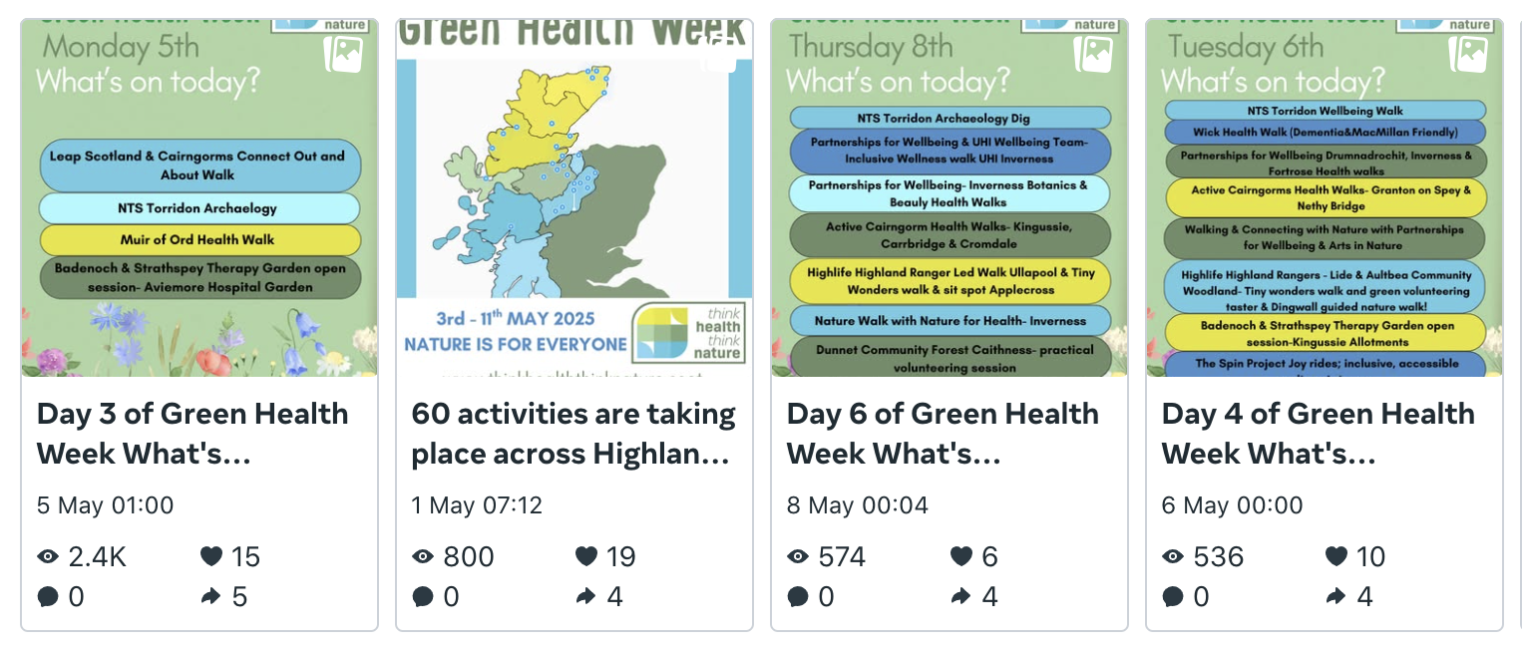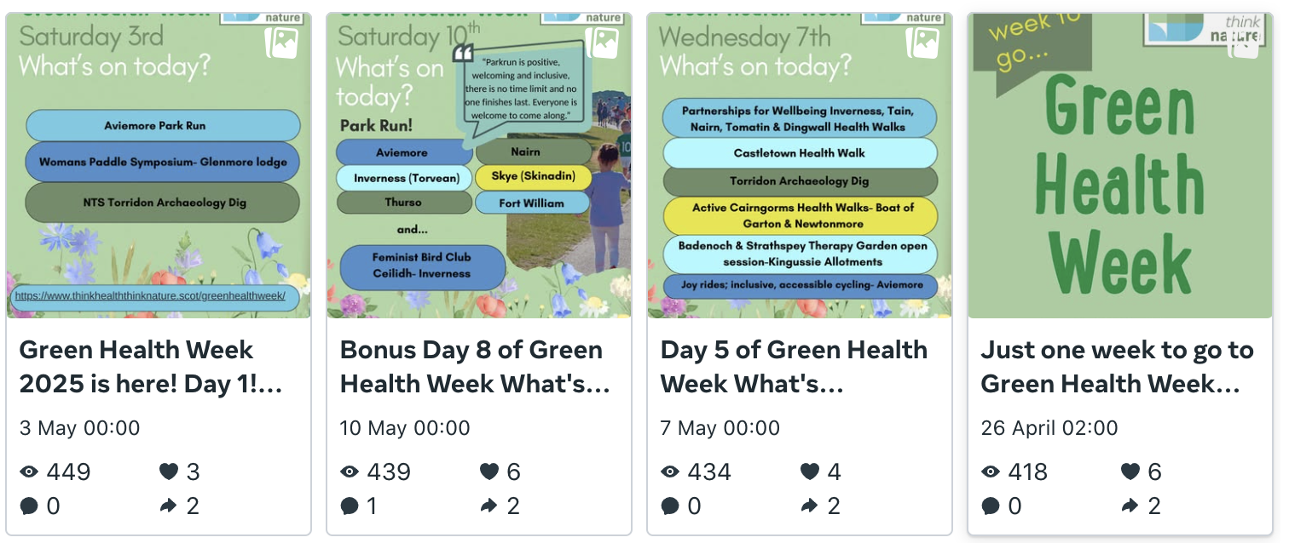

**Instagram**

Our Instagram page had **4100** views which is a 30% increase over the previous year (2885). There were **65** shares and **640** story views. Our reels had X views

We got **12** new followers and 4 unfollowed.

Below you can see the content and interactions by post: