Scotland’s

Mental Health

Charter

declaration

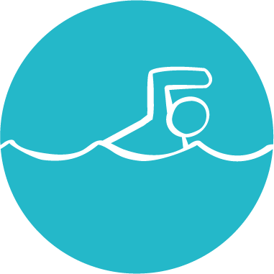of support

# 

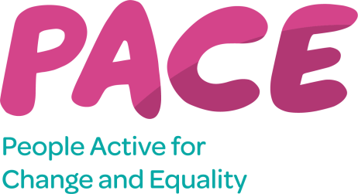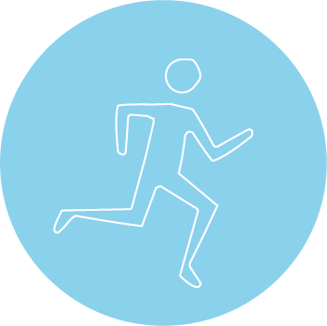





# Scotland’s Mental Health Charter for Physical Activity and Sport aims to improve equality and reduce discrimination for anyone with a mental health problem, ensuring there is no barrier to engaging, participating and achieving in physical activity and sport.

**To become a Charter signatory you must:**

* Complete the contact details section in your Declaration of Support.
* Submit your Statement of Support in your Declaration of Support.
* Submit your action plan in your Declaration of Support.
* Review Charter privacy policy included in the Declaration of Support.
* Complete the consent section in your Declaration of Support
* Return your Declaration of Support to [mhc@samh.org.uk](mailto:mhc@samh.org.uk).

**As a signatory we are committed to the following:**

* Actively promoting inclusive practice and ensuring a positive and welcoming environment for all.
* Developing inclusive policies and practices which are informed by the inclusion of mental health in strategic planning.
* Actively encouraging participation and promote messages focusing on the benefits of physical activity on mental health.
* Participating in Scotland’s Mental Health Charter Network supporting meaningful collaboration, sharing resources and best practise.
* Routinely reviewing performance and identifying ways to improve working in relation to mental health.

# Contact details and statement of support

|  |  |
| --- | --- |
| **Organisation** | **Highland Green Health Partnership** |
| **\*Name of lead contact** | **Helen Perkins** |
| **Position** | **Senior Development Officer** |
| **Phone number** | 07977814694 |
| **Email address** | **Helen.perkins2@nhs.scot** |
| **Organisation web address** | **www.thinkhealththinknature.scot** |
| **Date submitted** | **01.03.24** |
| **Organisation Statement in support of the charter. Please use the space below to compose a short statement on why your organisation chose to sign the charter.** | |
| * The Highland Green Health Partnership is one of four area-wide partnerships developed in Scotland, working to contribute towards "Our Natural Health Service", an action programme being led by NatureScot. Our aim is to encourage more use of the outdoors to tackle physical inactivity, social isolation and mental health issues by reducing barriers to allow more people to be physically every day and in doing so, tackle health inequalities. * **The Highland Green Health Partnership** and **SAMH** have a shared belief in the value of physical activity and sport as a means to achieve both physical and mental wellbeing | |
| X - We have completed the Action Plan Template as follows | |

Date: 26.1.24

Version: 1

|  |  |  |  |  |  |  |
| --- | --- | --- | --- | --- | --- | --- |
| **Focus Area** | **Action Description** | **How this will be delivered** | **Lead Person** | **Timeline** | **Success Measure or Outcome** | **Progress Update** |
| **Promotion Mental Health & Wellbeing benefits of connection with nature** | Promote mental health awareness training to green health activity providers and volunteers. | We have a dedicated training section on our website. We are developing training on nature prescriptions on TURAS that will include elements of mental health. When working with communities we conduct training needs assessments. | Helen Perkins | Sept 2024 | Number attending training. | 86 people have completed nature prescriptions online TURAS training and 129 people have engaged with the resource since its launch in May 2024. |
|  | Highlight available and upcoming online mental health awareness training via our website and newsletter. | Our monthly newsletter shares any relevant training with our distribution list. We also promote via our social media channels and website | Helen Perkins | Sept 2024 | Number of subscribers to newsletter | We currently have 247 subscribers to the Think Health Think Nature Newsletter. |
|  | Provision of resource to support mental health & wellbeing within Highland Communities, our green health activity providers and to individuals to support self-management. | We have a dedicated advice and guidance section on our website. Regularly distribute printed materials at community events and stalls and promote through social media and newsletter. We gain feedback on how resources have been received and used (e.g. our nature almanac) | Helen Perkins | Sept 2024 | Numbers printed/  Downloaded. feedback | Annual report totals of resources used-  Our Natural Health Service Leaflet - 91 Tree ID - 200 Shells ID - 175 Birds ID - 191 Health Walk Journal - 311 Nature Apps - 290 Think Health Think Nature Postcard - 405 Think Health Think Nature Almanac - 426 Your natural pathway to recovery and health (A4 poster) - 28 Your natural pathway to recovery and health (A3 poster) - 43 Caithness nature prescription booklet – 21 |
|  | Work with SAMH to plan a minimum of 4 communications to our members per year promoting mental health and wellbeing including through our monthly newsletter and via campaigns on social media. | We will ensure our communications officer is linked with the messaging coming from SAMH and aligns our campaign work accordingly | Sophie Isaacson | June 2024 | Communicate launch of charter, use social media to communicate key messages and use other comms opportunities with green health providers to share experiences & good practice. | Standing item in newsletter that relates directly to mental health and regularly posting on socials about benefits of green health for mental health and wellbeing.  We use SAMH messaging where appropriate for example #feelpartofsomething this winter included in socials and newsletter. |
| **Share good practice** | Invite partners to share case studies and personal stories of the benefits of physical activity on mental health for groups with varying health needs. | We have a library of case studies building on our website. Need to ensure they have appropriate balance of mental health messaging across different groups. | Sophie Isaacson/All Partners | Sept 2024 | Case Study Template and section on our website at www.thinkhealththinknature.scot | One case study provided by Cairngorms National Park on benefits for young people not engaging with school in engaging with nature based programme. |
|  | Continue to raise profile of nature based activities with the Highland Mental Health Delivery (MHDG) group. | Attend MHDG quarterly and deliver joint actions where appropriate. The MHDG feeds in to the Community Planning Partnership and there is opportunity to influence there. | Helen Perkins/Cathy Steer | Ongoing |  | Senior Development Officer attended and shared work and raised profile of green health. Since funding end representation is continued through Ailsa Villegas (Health Improvement Specialist, NHS Highland). |
| **Monitor Our Progress** | Continue to look for way to measure and monitor the mental health impacts of the work we deliver. | Work within our partnership to gain insights on appropriate measures to include | Helen Perkins | Ongoing |  | This is ongoing work and there are several research projects underway.  University of Highlands and Islands to evaluate impacts of upcoming projects in Kinlochleven and Ullapool through ‘Stepping Stones’.  [Healthy Young Minds](https://www.southwales.ac.uk/news/2024/may/mental-health-awareness-week--promoting-mental-well-being-through-engagement-with-nature/)- University of Wales, implementation of green health activity across several high schools in Highland  [Innovation Fund Challenge](https://www.nhshighland.scot.nhs.uk/news/2025/02/highland-health-board-endowment-funds-charity-awarded-98-200-as-part-of-nhs-charities-together-s-innovation-challenge-fund/) Aberdeen University, focussed on green health activity for young people and their wider family network in Inverness & Fort William, facilitated by a youth worker linked closely to CAMHS. |

# Information for Charter Map

Once your action plan has been approved, we’ll add you to the Charter map so that people in your local area can find out about your activities.

Please provide the following information for each location that you operate in.

|  |  |
| --- | --- |
| **Postcode** | **Brief description of what is on offer (max 300 characters)** |
| **IV2 7PA (All Highland Council)** | We offer a website and directory of nature based activities across Highland where individuals and those supporting individuals into improved health & wellbeing programmes, can search for available opportunities in their locality. We also offer a number of self-led activities available to download and print and have published a number of guidance documents for professionals. We run networking events and have a monthly e-newsletter as well as linking groups to appropriate training programmes. |
|  |  |
|  |  |

Checklist:

* Review the Mental Health Charter action plan to reflect the key areas within the Charter.
* Complete your Declaration of Support.
* Submit your Declaration of Support and Action Plan.

Next steps:

Once you receive the Mental Health Charter Logo;

* Promote your involvement in the Mental Health Charter through partners and relevant stakeholders.
* Be actively involved in Scotland’s Mental Health Charter Network.
* Live the Charter – deliver your action plan and help improve equality and bring about positive change

Signature of Lead Contact: **An Example**  Date: **25/05/21**

**\*Upon completion please return to mhc@samh.org.uk. Please note your organisation will be added as a signatory for two years from date of approval. Following this you will be invited to resubmit an updated Declaration of Support.**

# Mental Health Charter Privacy Statement

SAMH’s Privacy Policy can be found on our [website](https://www.samh.org.uk/information/privacy-cookies). The following Privacy Statement is specific to the Declaration of Support to Scotland’s Mental Health Charter for Physical Activity and Sport.

In signing-up to the Charter you are agreeing to SAMH processing your information as follows:

**Signing up to the Charter**

SAMH will collect the following information:

* Name of Lead Contact
* Position
* Name of Organisation
* Telephone numbers, email address, website details.

In addition SAMH will collate information relating to your ‘statement’ and ‘action plan’.

**Looking after your data**

* The information will be stored on our database, please see SAMH’s Privacy Policy on our [website](https://www.samh.org.uk/information/privacy-cookies).
* We will undertake to protect the information you share with us in line with data protection regulations.
* We will review the data every two years to ensure it is relevant and remains valid.

**Using your data**

We will use the data you provide to:

* Promote the Mental Health Charter – by advertising the name of the organisations who are signed-up.
* Demonstrate good practice: through case studies; but we will anonymise the information before we share it (unless you give us consent in advance – see below).
* Highlight positive action being taken: by using examples; but we will anonymise the information before we share it (unless you give us consent in advance – see below).
* Generate statistical reports (for example on the level of activity; number of organisations participating) which will be shared publicly.

**Your rights**

Please refer to our [Privacy Policy](https://www.samh.org.uk/information/privacy-cookies).

**Consent**

Please tick the following boxes where you wish to ‘opt-in’:

**YES** - I agree to SAMH using the information I have provided without anonymising it to demonstrate good practice; developing case studies and highlighting positive action

**X** - I would like to receive more information about SAMH’s work.

**X** - I would like to find out more about supporting SAMH.

# For more information about the Charter please contact: [mhc@samh.org.uk](mailto:mhc@samh.org.uk)

# 