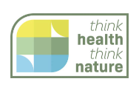

Think Health Think Nature
Case Study Template

Thank You for agreeing to be a case study of good practice. Below is a short template we would be grateful if you could complete and return, with any images to ailsa.villegas@nhs.scot

All of our case studies are used to report back to the Scottish Government the good work underway in Highland and it is hoped that they will make the case for continued support for Green Health Initiatives in the future. We will also feature the case study on our website at www.thinkhealththinknature.scot to help inspire and encourage others.

Your time is appreciated and valued.

Summary (50 words who engaged, resulting in what benefits?)
Introduction to the activity and delivery organisation (inc. what health / well-being issues and key user/client group)
Location

Key learning points
Testimonials (optional)
Future plans / next steps
More information (provide contact details or web address where further information can be found)

